Step 1: Generate the SSL certificate using Free SSL sites like Punchsalad.com etc……

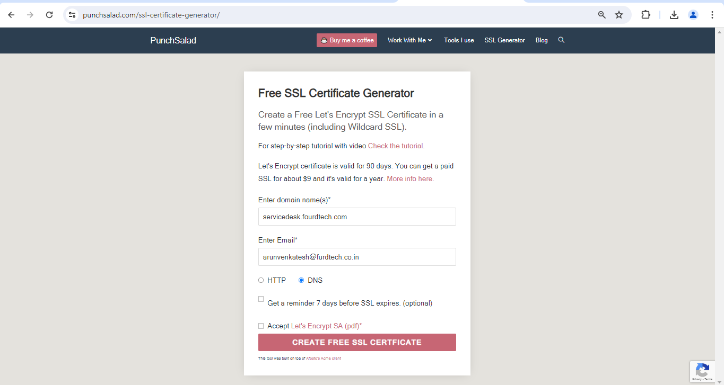

Step 2: Add the txt record to the domain registrar and verify the records.

Step 3: After verifying the records, the SSL certificate will be generated and download the bundle and private key.

Commands used in Linux machine for renewing SSL.

Cd – Change Directory

Vi - Vim Editor

*Vim Editor commands*

:wq! - Modify and exit

:q! – exit

mv – Move / Rename

Linux commands:

Login to VM 172.16.5.157 using username and password.

Goto conf directory using the below command.

Cd /etc/httpd/conf

edi

Vi httpd.conf



